ASSIGNMENT 6.1 :-

1. Find out how many people has chosen their destination as MIA and MCO

DRIVER :

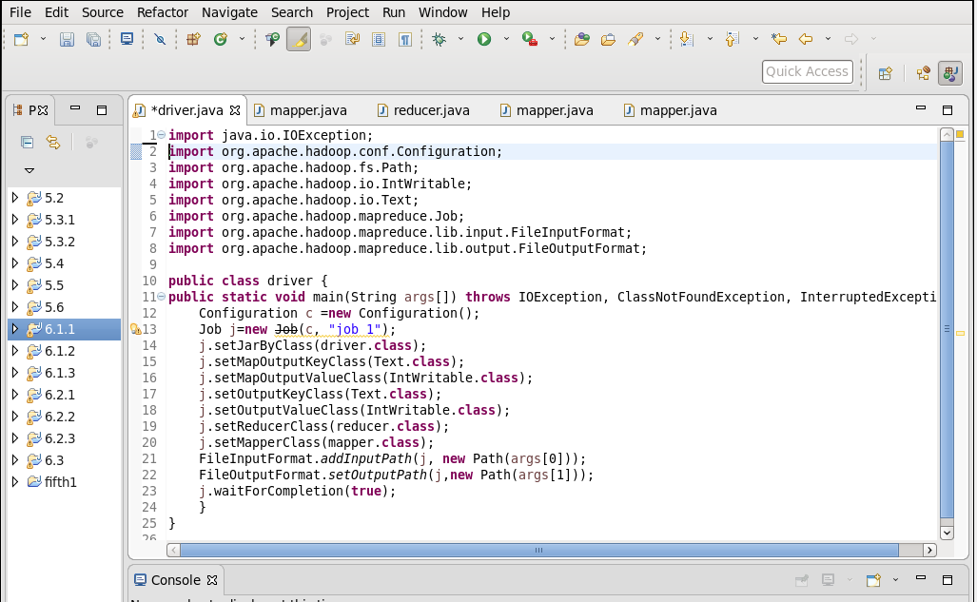

MAPPER :

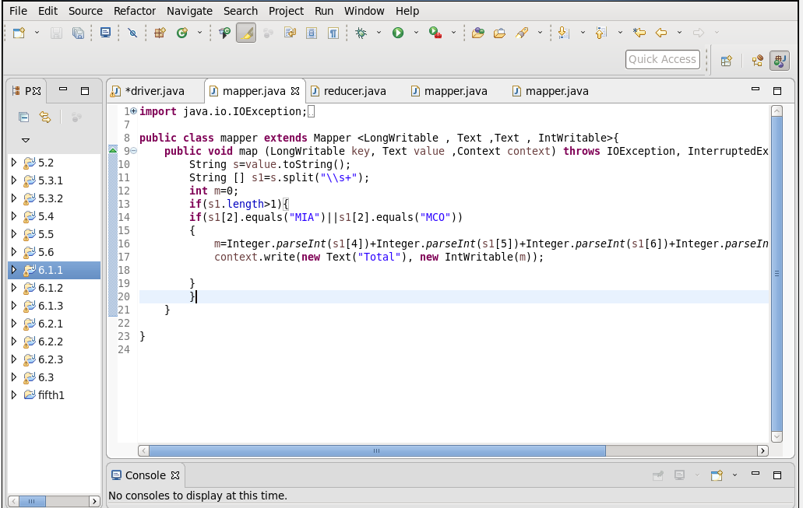

REDUCER :

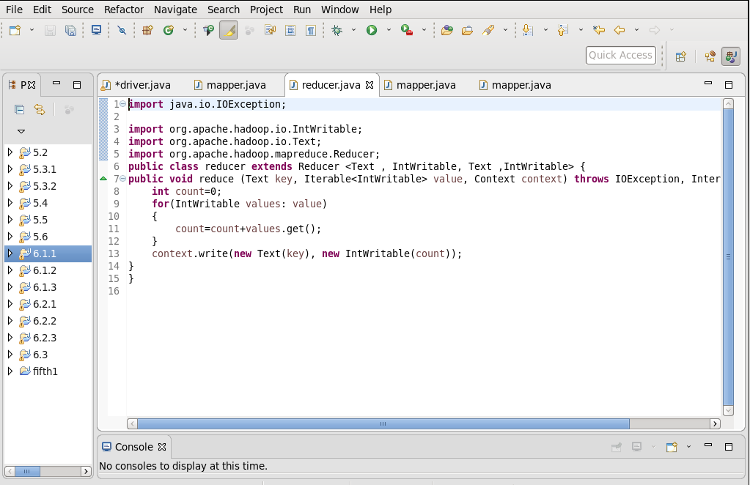

OUTPUT

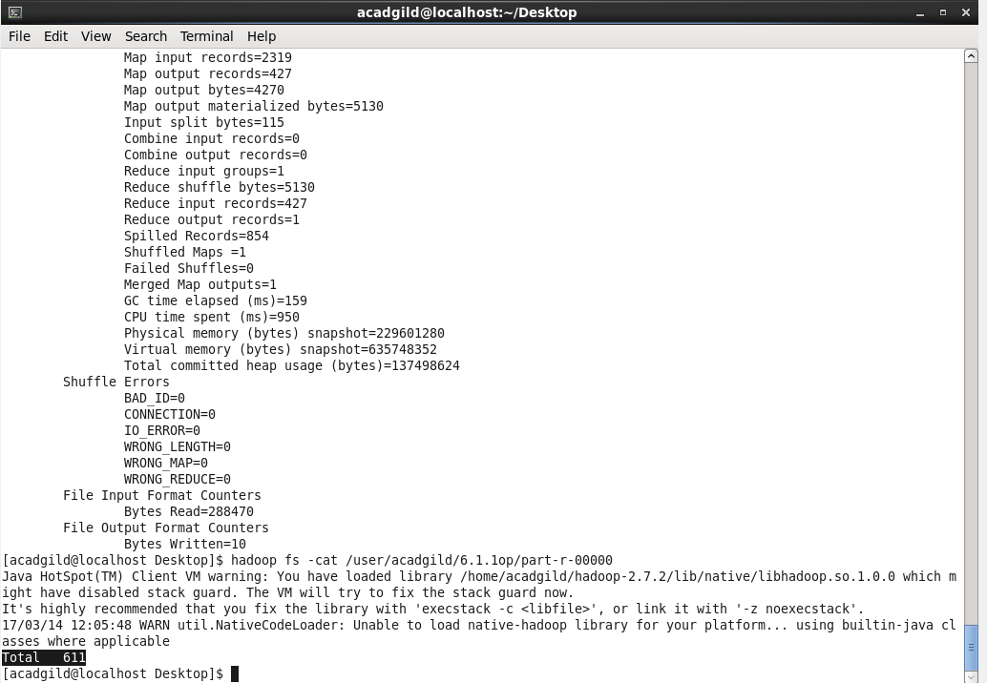

1. Find out the number of people undertaken the trips from the places MIA and HOU

DRIVER :

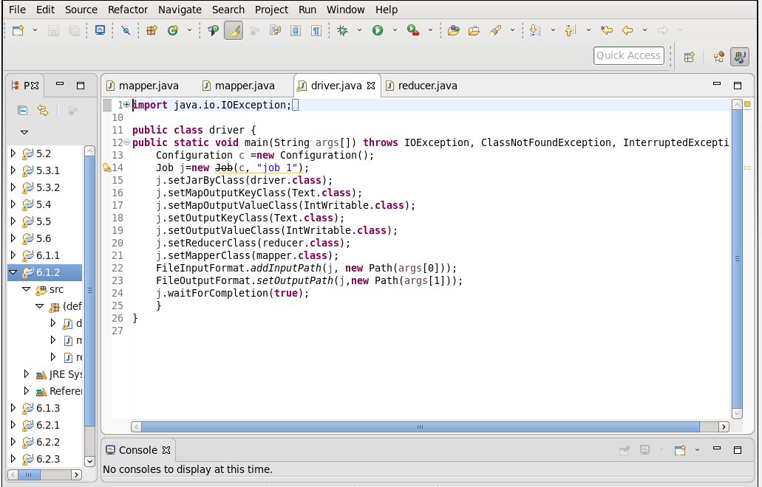

MAPPER :

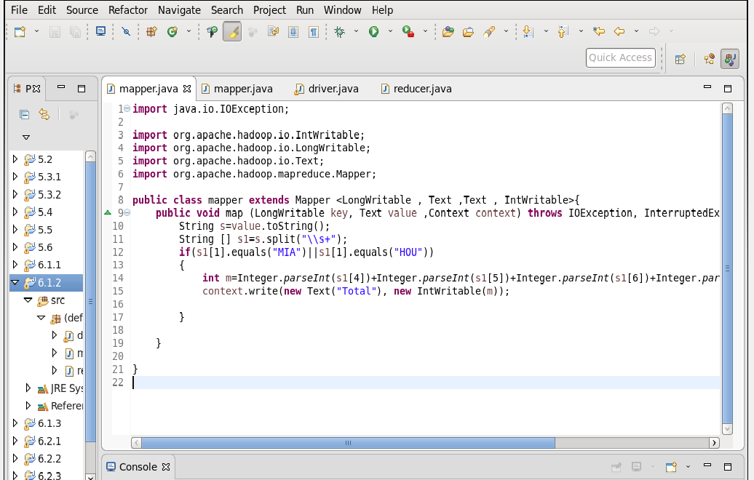

REDUCER :

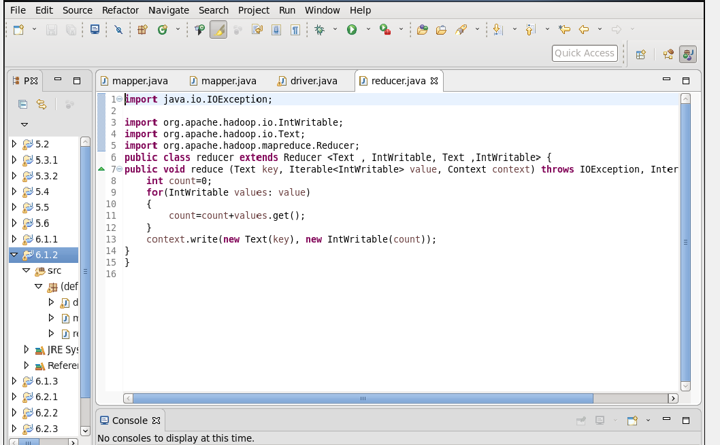

OUTPUT :

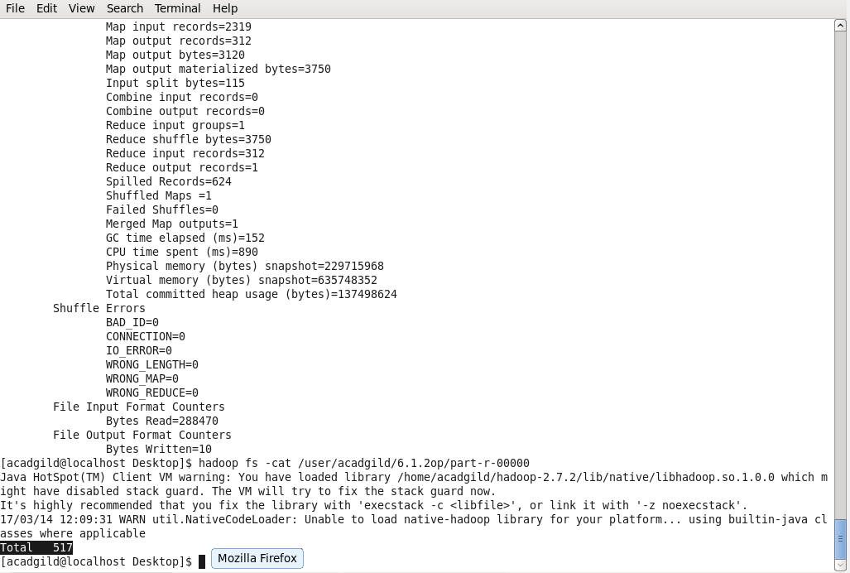

1. Find out how many people has chosen airline mode of travel for the places LAS and LAX

DRIVER :

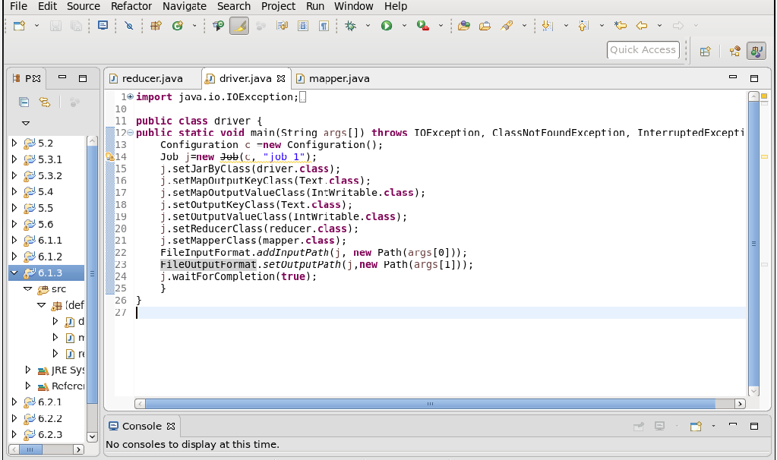

MAPPER :

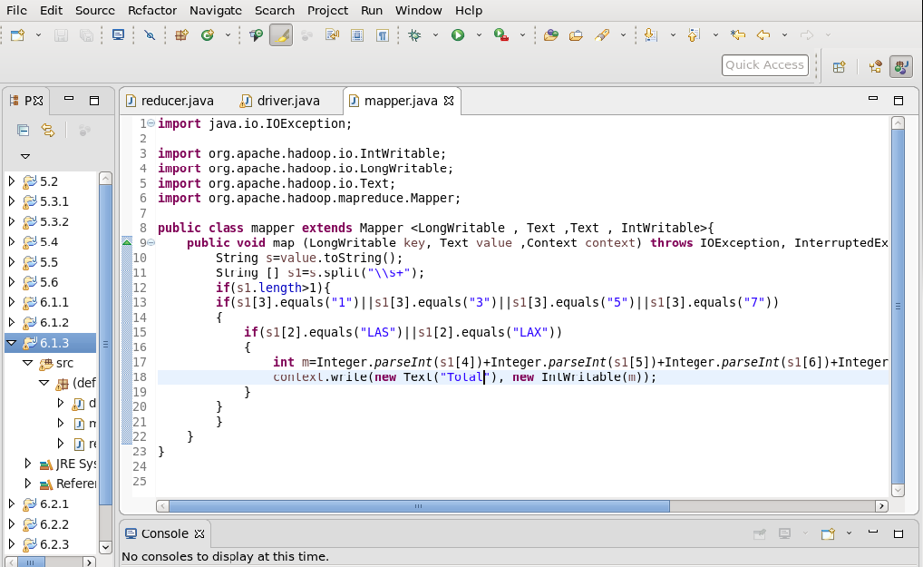

REDUCER :

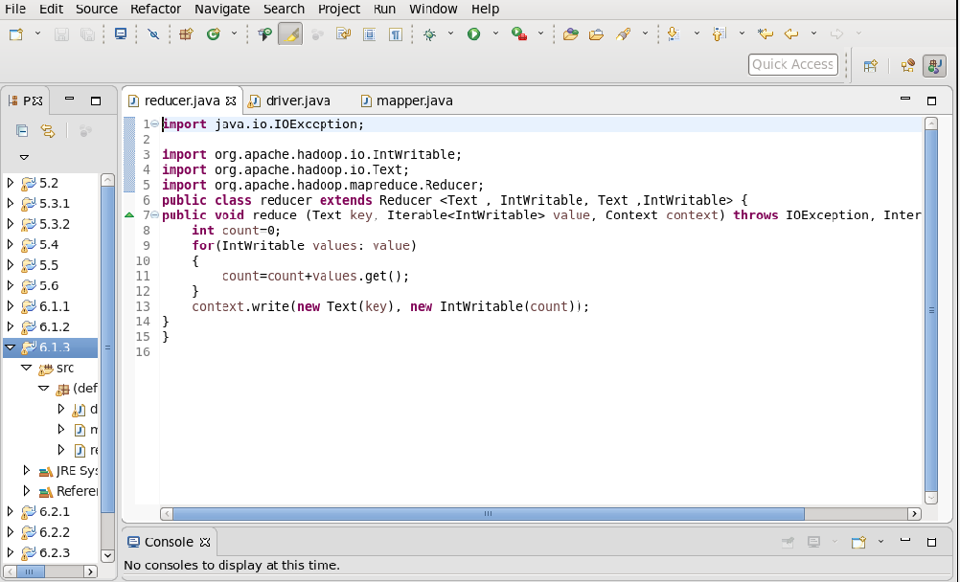

OUTPUT :

